|  |  |
| --- | --- |
| **New Vocabulary** | |
| Absorbent | able to soak up liquid easily |
| Opaque | not able to let light through |
| Transparent | can see light shining through it and what's on the other side of it |
| Translucent | can see light shining through it, but can't see clearly what's on the other side of it |
| Reflective/ Non-reflective | provides a reflection/not capable of reflecting light |
| Rigid | unable to bend or be forced out of shape |
| Flexible | can be bent easily without breaking |

 

**Career links**

Material engineers work with metals, ceramics, and plastics to create new materials.

Recycling waste operatives sort, process and load recyclable materials.

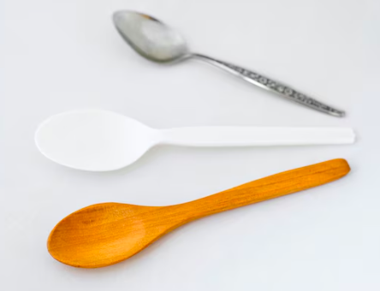

**Did you know….**

Rock is a material not an object?

Materials include more than just fabrics?

‘Solid’ does not just mean ‘hard’?

**Prior Learning**

**In EYFS, pupils learnt…**

To use techniques such as: pinch, roll, twist, roll to change the shape of playdough and clay. (DT/ART link)

To use their senses to explore different everyday objects and materials – how they look and feel.

Some material names such as plastic, wood, paper and card.

**New Knowledge**

All objects are made of one or more materials.

Some objects can be made from different materials e.g. plastic, metal or wooden spoons.

Common materials include plastic, glass, wood, rubber, metal, brick, paper and cardboard.

Materials can be described by their properties e.g. shiny, stretchy, rough, rigid, flexible etc.

Some materials, like plastic, can be in different forms with very different properties.

The material of objects is chosen specifically because they have suitable properties for the task. For example, a drinking bottle is made of plastic because it is transparent, allowing you to see the drink inside and is waterproof so that it holds the water.  
Some materials can be opaque, translucent, transparent or reflective/non-reflective.

MATERIALS - Cycle A

SUMMER TERM 1 - Y1/2

**Topic: Science**