**Science – Light**

Miss Read is in a dark room. She can hear properly and her eyesight is perfect but she can’t see the person making a noise. Why not?

**Key Knowledge**

We see things when light enters our eyes. Light is reflected form surfaces and travels in straight lines.

Darkness is the absence of light.

Shadows are formed when the light from a light source is blocked by an opaque object. They can change size depending on the distance of the object causing the shadow from the light source.

Light from the sun can be dangerous because of Ultra Violet rays which can damage the eye.

**Key Vocabulary**

**Light source:** Objects that give out light are called sources of light

**Iris:** the coloured tissue at the front of the eye that contains the pupil in the centre

**Pupil:** The round opening in the centre of the iris

**Cornea:** The transparent part of the eye that covers the iris and the pupil and allows light to enter the inside

**Reflect**; to throw back light

**Opaque**: allows no light to pass through

**Transparent**: allows all the light to pass through them

**Translucen**t: allows partial light to pass through

**Computing – Branching Databases**

**Key Knowledge:**

Groups of objects can be created by asking yes or no questions.

Objects can be arranged in a tree like structure where they are separated by one attribute.

Branching data bases can be tested to see if they work by answering the yes/no questions.

Questions need to be ordered carefully to split objects into similarly sized groups.

**Key Vocabulary**

**Branching database:** A branching database attribute

is a way of classifying a group of objects. If it has been designed properly, someone else could use the tree to identify one of the objects

**Attribute:** a characteristic something has

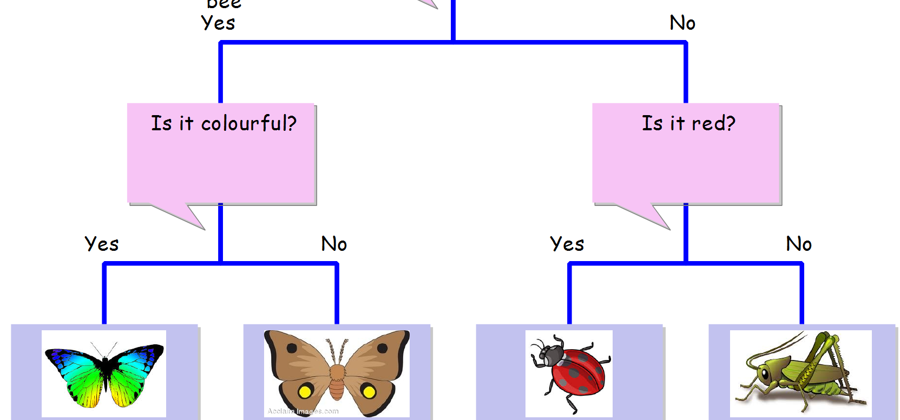

**Author of the term:** C. S. Lewis

**Power of reading book:** Arthur and the Golden Rope

**Poetry:** Poem to Year 6

**The Moon**

**The Crocodile**

**From a railway carriage**

**My Shadow**

**The Moon**

**D.T. - Textiles – Anglo- Saxon purses**

**Key knowledge**

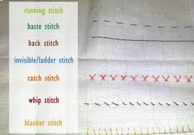

The purpose of purses is to hold things securely.

There are a variety of stitches we can use to sew material together. These are:

**running stitch**: A simple line of evenly-spaced

stitches that go straight along the

fabric without overlapping

Key Vocabulary

**invisible stitch**

**back stitch**: Overlapping stitches

**whip stitch:** joining fabric together with an overlapping stitch

**tacking stitches:** quick, temporary stitches that will later be removed

**hemming stitch:** straight stitch with a medium length

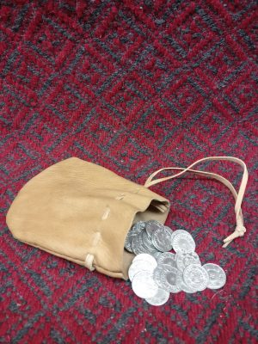

**Music – Ukulele**

**Key Knowledge/ Vocabulary**

Ukulele, pitch, rhythm

Key notes: C, D, E, F, G, A, Am, B, Bm, Cm, Em, Fm, Gm

**Key Knowledge:**

We can play the C, D, E, F, G, A, Am, B, BM, CM, EM, FM and GM chords on a ukulele.

We can play simple rhythms on the ukulele.

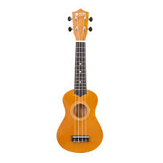

**Geography – Fieldwork: Local hill and tourism**

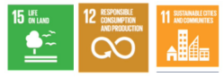

**Key Knowledge**

To be able to locate Roseberry Topping on an OS map and identify significant symbols using the key.

To conduct fieldwork at Roseberry Topping to observe, measure and record human and physical features in the local area.

To observe and identify physical and human featured from the map.

To draw a sketch map of the area showing simple annotations of human and physical features.

To interpret and present findings in a bar chart.

**Key Vocabulary**

**Tourism:** When people travel from where they live to another place for pleasure or relaxation.

**OS Map:** Ordnance survey map.

**Map symbols:** Images that help to identify significant places when reading a map.

**Sketch map:** Simple drawings of the landscape.

**Distance:** How far one thing is from another thing.

**RE – How and why do people pray?**

**Christianity and Judaism**

RHE: The importance of respecting others

British Value: Respect and tolerance

**Key Knowledge**

Pray is about friendship, love and support.

Prayer is important to Christians as it is their time to talk to God and be close to him.

Christians have a special prayer that was taught to them by Jesus called ‘The Lord’s Prayer’.

Christians pray when they are sorry (confession) and thankful (intercession).

When Jewish people pray they: pray 3 times a day, wear a Tefillin (small black box) which contains sections of the Torah written on parchment, they wear a Kippah (skill cap), a tallit (prayer shawl) and they hold a prayer book.

Prayers play an important role within Judaism, it strengthens the relationships which humans have with the Almighty.

There are many commandments associated with prayer.

They pray for thanks and forgiveness.

**Key Vocabulary**

**Confession:** A way for people to be forgiven of their sins, or things they do wrong.

**Intercession:** A prayer for other people.

**PSHE- Money Matters**



**Key Knowledge and Vocabulary**

Money can be a **factor (a point to consider)** that influence people’s career choices.

Things can be paid for in different ways.

There are risks associated with money such as gambling which can affect mental wellbeing.

Spending decisions can be based on **priorities (what people believe are the most important things),** needs and wants.

Spending can affect others and the environment (for examples buying Fairtrade items.)

Adverts try to influence spending.

That keeping track of what you are spending is important to help manage **budgets (a plan for saving and spending.)**

**P.E. – Athletics**

**Key Skills & Vocabulary**

**Year 3**

To pace myself during a long-distance run (at least 1 lap of the field).

To jump and turn in the air to face a different way.

To pursue/chase a target, following their path exactly.

To stop myself quickly and carefully when running at speed.

To hop, then step then jump and land on 2 feet (triple jump).

To push myself to triple jump further, using a run up and arms to propel me.

To sprint, do a preparation jump (heel, toe, push up) then sprint again.

To change direction to avoid others.

To improve my high or long jump by using arms and legs to push up.

To apply my running and jumping skills in a competitive situation (dodgeball, relay races, hurdles or ladder races).

**Year 4**

To run over low obstacles, clearing them most of the time.

To sprint correctly, starting off in a bent position, straightening up.

To run for 1.5 laps of the field (approximately 1200m) pacing myself.

To run with an object in my hand without dropping it.

To pass and receive a relay baton without dropping it.

To demonstrate 4 changes in speed (walk, jog, run, sprint).

To use heel, toe, push up (preparation jump) to jump high.

To use a range (at least 5) different foot patterns in ladders or around cones.

To jump sideways over a small obstacle repeatedly for 30 seconds (speed bounce).

To run and jump over higher obstacles (hurdles) and clear them most of the time.

**French**

**Key Knowledge & Vocabulary**

To read & write numbers to 12

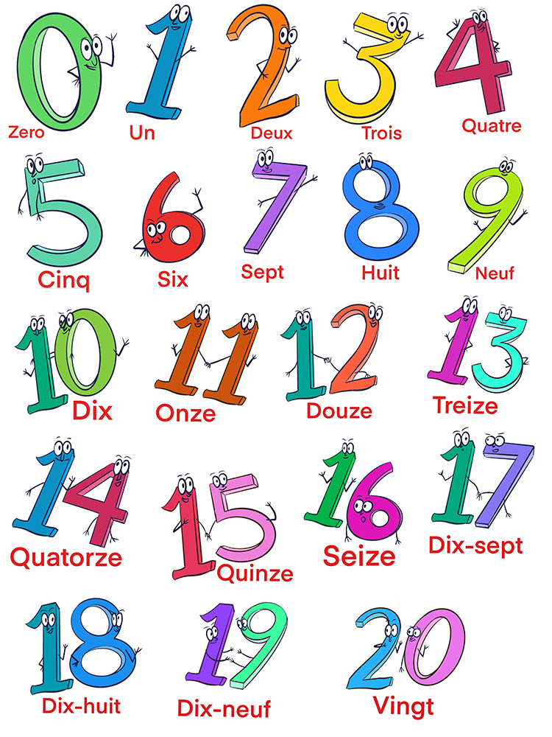

To recalls the use of the 2 words for ‘a’ – un (masculine) une (feminine)

To write sentences with cest (it is) and questions with est ce ( is it)

Pourquoi- why

Jai- I have, tu as- you have

Je n’ai pas de- I do not have

**Grammar**

To know the position of a colour adjective in a sentence, coming after the noun.

**Phonemes/ Graphemes**

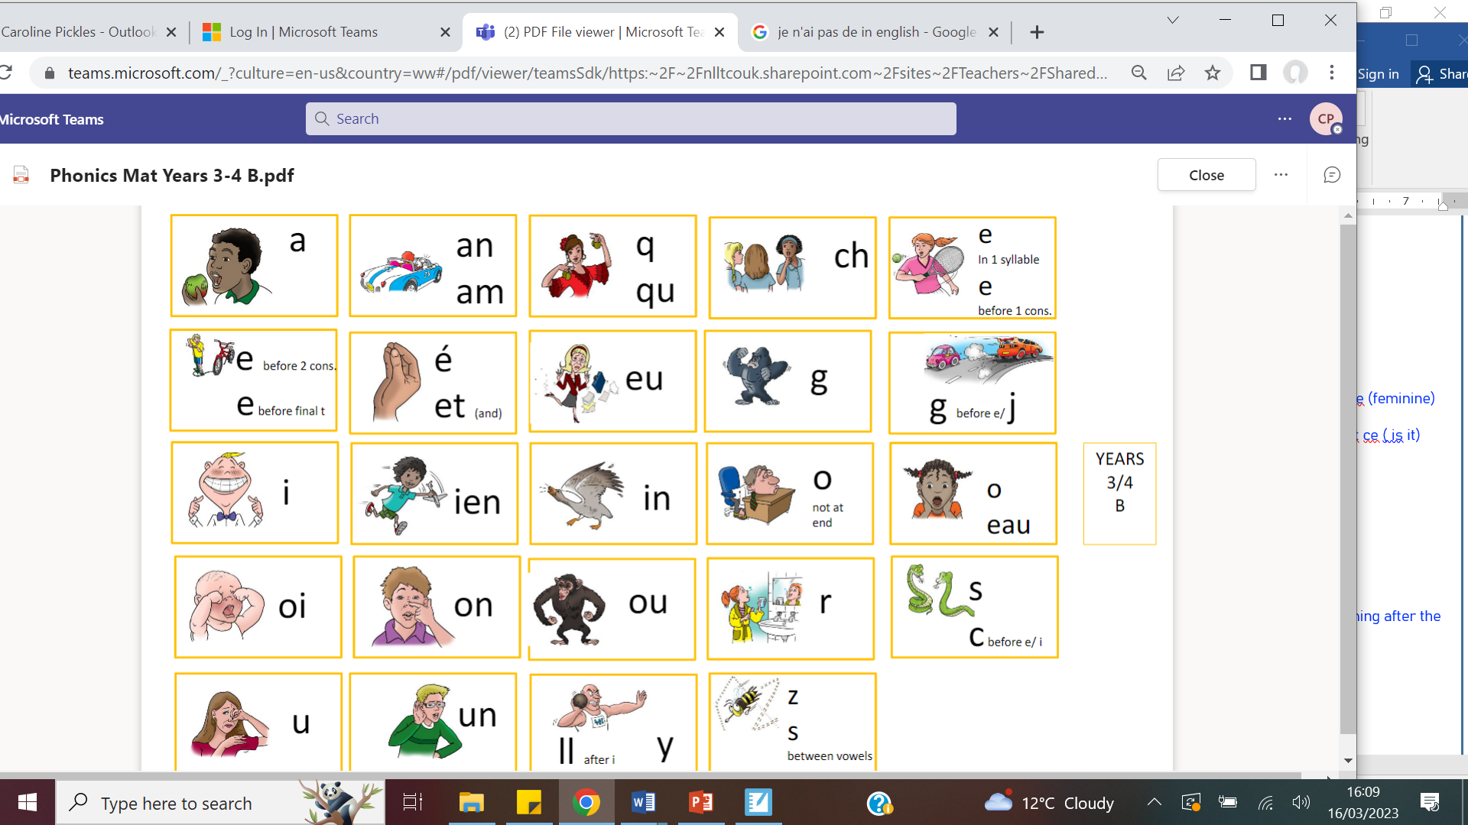

Silent