**Author of the term: David Walliams**

**Power of reading book: The Iron Man by Ted Hughes**

**Poetry: Robert Louis Stevenson poems:.** **The Crocodile, From a railway carriage**

**The Moon**

**The Crocodile**

**From a railway carriage**

**My Shadow**

**The Moon**

**Science – Plants**

Where have all the tulips gone?

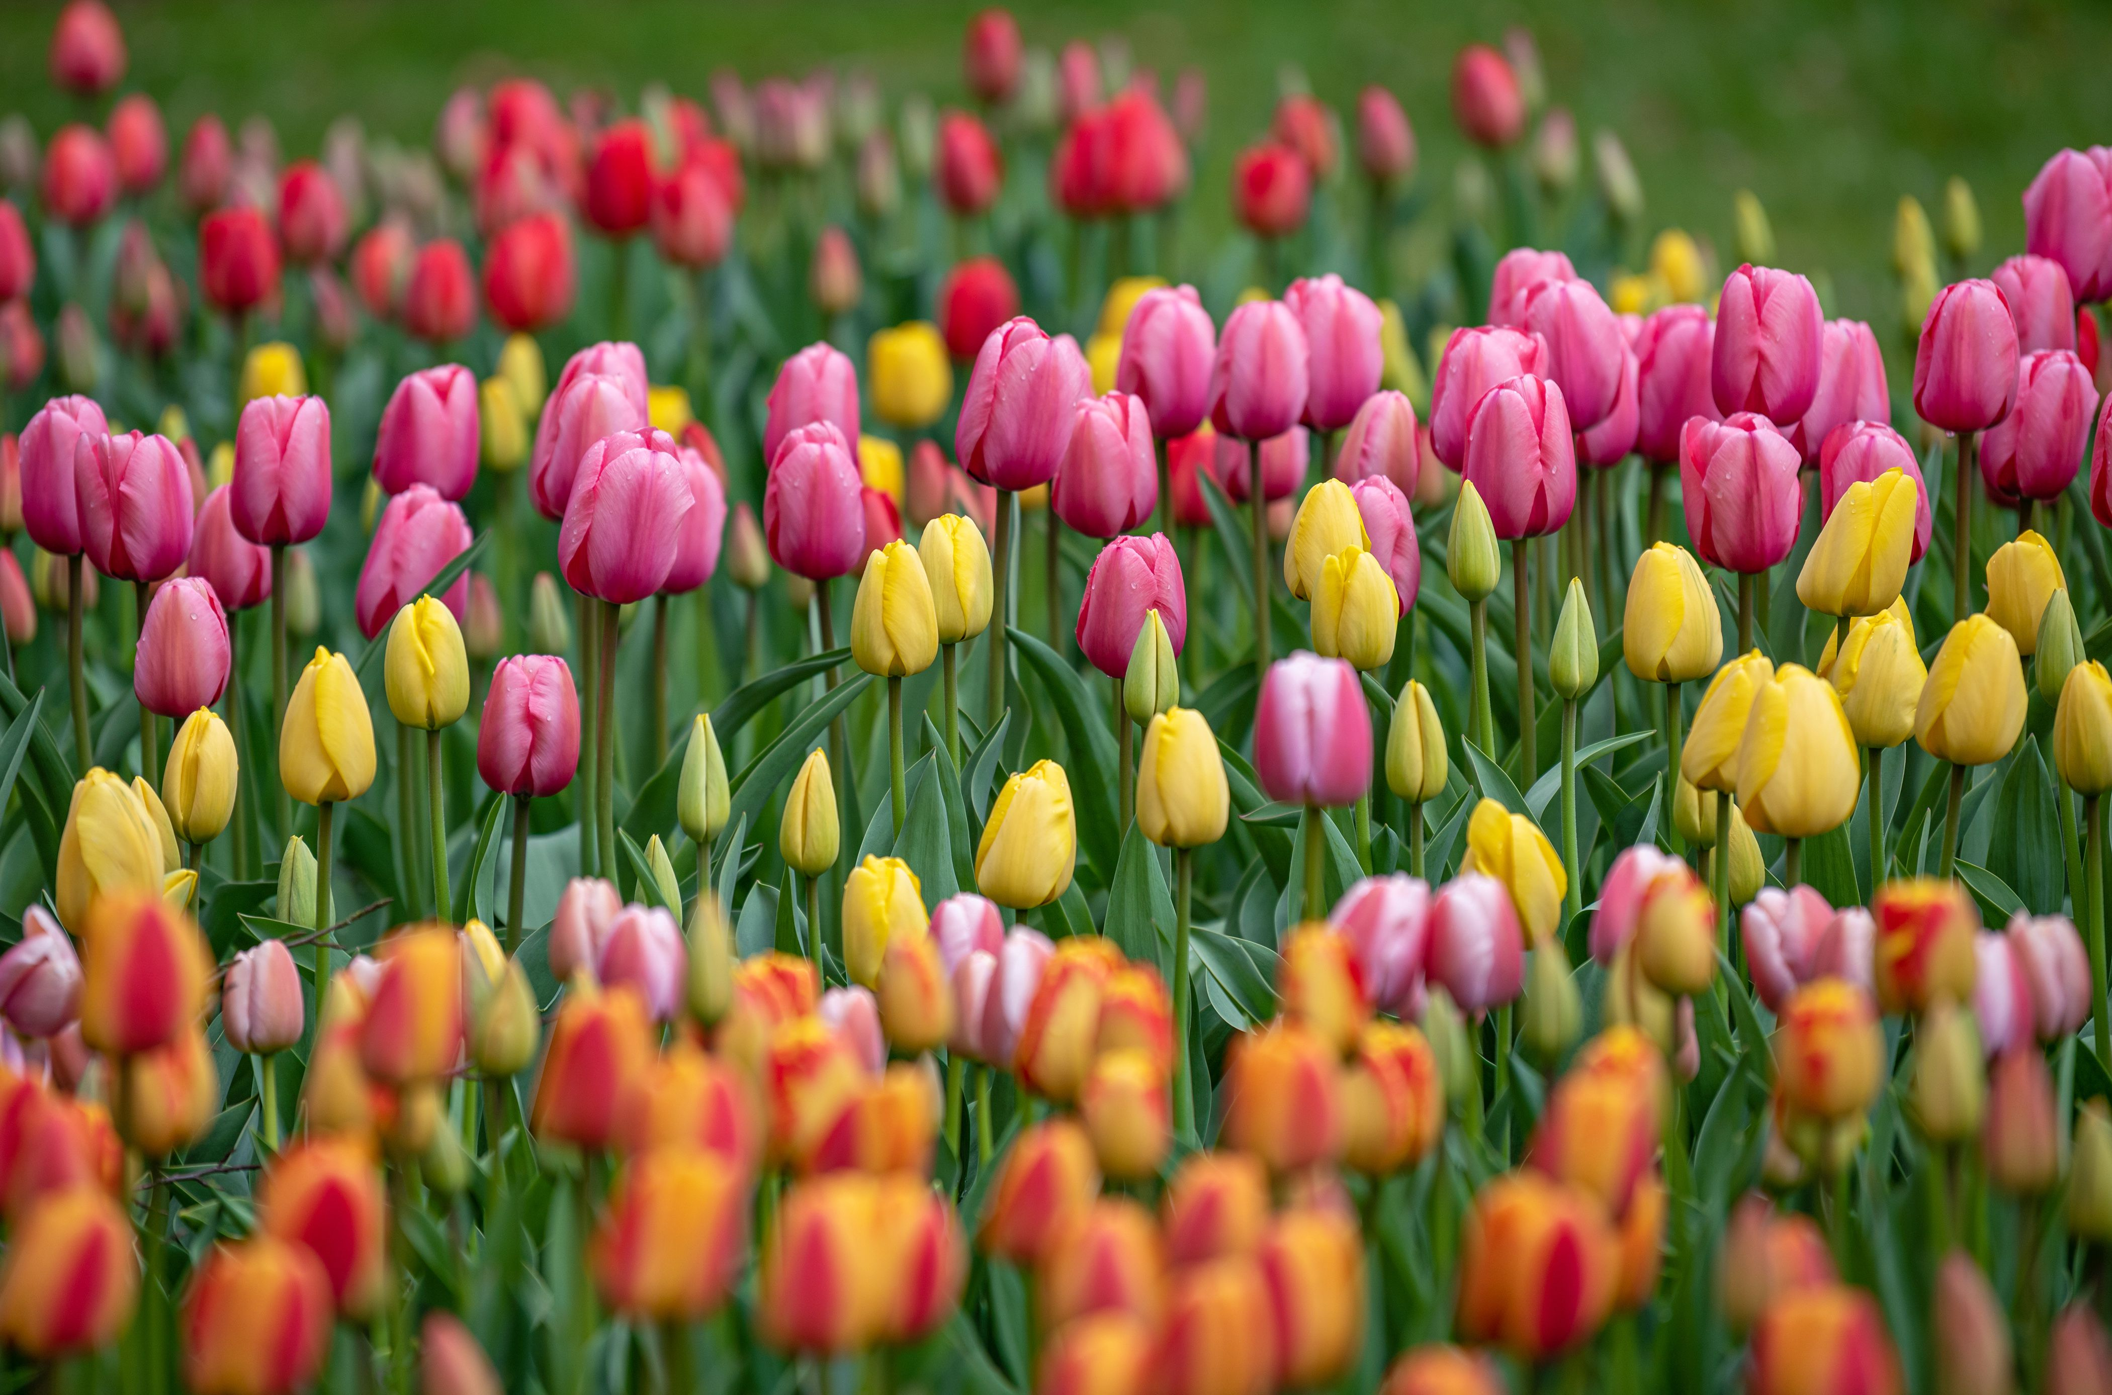

**Key Knowledge and Vocabulary**

Key Knowledge and Vocabulary

That plants are made up of a variety of parts. Each part of the flowering plant plays a different but important role in keeping the plant alive.

The roots absorb water (through the capillary roots) and nutrients (through the trunk roots) from the soil and transport them to the plant. They also anchor the plant firmly into the ground.

The stem supports the branches, leaves, flowers and fruits, ensuring the plant stays upright. It also helps in the transportation of water and minerals to other parts of the plant.

The leaves produce the food for the plant by a process of photosynthesis.

The bud is a small growth the develops into a flower, leaf or branch on the plant.

The sepal protects the plant and acts like a support structure for the petals.

The flowers are the part of the plant that is responsible for making the food. It is split into male and female parts which fertilize the plant and produce seeds.

**Design and Technology**

**Design Brief: To make a healthy dish including naturally grown produce.**

**Key knowledge:**

To be healthy, we should aim to eat more fruit and vegetables and carbohydrates than fat and dairy.

A variety of food is needed in the diet because different foods contain different substances that are needed for health – nutrients, vitamins and minerals.

The plate above shows the correct proportions for a balanced meal.

I will know where and how a variety of common ingredients are grown.

I know some fruits and vegetables that are grown in the UK: strawberries, raspberries, apples, pears, cherries, plums, carrots, potatoes, tomatoes, onions, turnips, cabbages, parsnips, squash, beetroot, and celery.

Seasonal fruit and veg are those that are ripe and ready to harvest at a particular time of year.

The weather can affect plants and how well they grow.

**Key Skills:**

To cut food using the claw hold technique independently.

Control the temperature on a hob.

Measure ingredients to the nearest millilitre accurately and assemble or cook ingredients.

Prepare ingredients safely and hygienically using appropriate kitchen utensils.

**Key Vocabulary**

•Bread, rice, potatoes, pasta and other starchy foods •Carbohydrates and starches.

•Milk and dairy foods• Meat, fish, eggs, beans and other non-dairy sources of protein;

•Sugars and fats •Seasonality •Flavour •Home grown

•Naturally grown •Organically grown •Produce •Millilitre

Degrees Celsius

**Computing – Word Processing**



**Key Knowledge:**

We can select, use and combine a variety of software (including internet services) on a range of digital devices.

We can design and create a range of programs, systems and content for given goals.

We can collect, analyse, evaluate and present data and information in a variety of ways.

**Key Vocabulary:**

Highlighting: Draw special attention to some text by marking it in a different colour.

Font: Printable text characters in a specific style or size.

Alignment: The appearance of the text in a paragraph.

Tab key: To move several spaces across.

**Music Combining Elements to Make Music Name**

**How Does Music Connect Us With Our Past?**

**Key Knowledge**

**Andante** is the musical term for ‘at a walking pace’

There are 2 crotchet beats in a bar (2/4)

F major scales have one flat in the key signature

To place the notes CDEGA on a stave

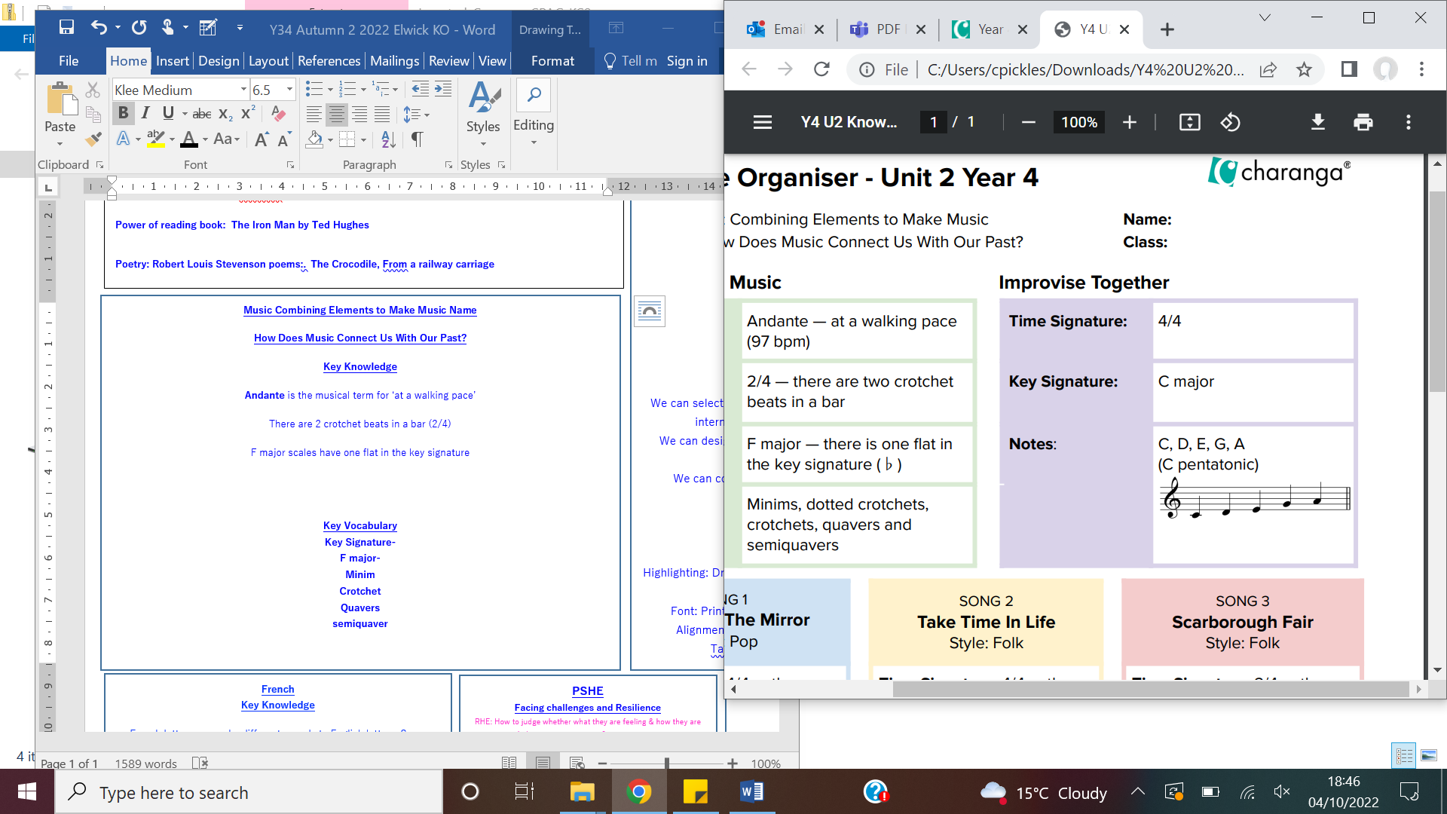

**Key Vocabulary**

**Key Signature-**the arrangements of notes on a stave **F major-** a scale based on the note F **Minim-** a half note **Crotchet-** a note with one beat **Quavers-** a note lasting for half a beat **Semiquaver-** a note played for half the duration of a quaver

**PSHE**

**Facing challenges and Resilience**

RHE: How to judge whether what they are feeling & how they are behaving is appropriate & proportionate:

I know the different types of bullying, the impact, and responsibilities of bystanders & how to get help.

That bullying (including cyber bullying) has a negative & often lasting impact on mental wellbeing.

I know how to recognise if family relationships are making me feel unhappy or unsafe & how to seek help or advice from others if needed.

I know how to ask for advice or help for themselves or others, and to keep trying until they are heard

**Key Knowledge**

I can identify positive things about myself and my achievements, seeing my mistakes, making amendments and setting personal goals.

You can resolve differences by looking at alternatives, making decisions and explaining choices.

I can recognise different risks in different situations and then decide how to behave responsibly.

I can face new challenges positively by collecting information, looking for help, making responsible choices and taking action.

My actions can affect myself and others, I need to care about other people’s feelings, and to try to see things from their points of view.

I understand the risks and the effects of risky behaviour and can develop strategies to cope with dangerous situations caused by others.

I know to judge whether what they are feeling & how they are behaving is appropriate & proportionate

Road Safety Week

I know the Stop, Look, Listen, Think sequence and safer places to cross the road.

I know my responsibilities as a pedestrian, a cyclist, a passenger in a car or on public transport.

**French**

**Key Knowledge**

French letters can make different sounds to English letters. Some French speaking countries are France, Belgium, and Switzerland.

We can write simple sentences with the conjunction ‘and’ & ask simple questions with rising intonation.

**Key Vocabulary**  
 Ne and pas – not. Two ways to say you in French – tu/vous. Voici – Here is. Et - and. Un/une – a.

Greetings  
Bonjour – Hello/Good day! Monsieur – Sir. Madame – Lady. Au revoir – Goodbye. Salut – Hi.

Colours  
Rose – Pink. Orange – orange. Brun – Brown. Blanc – White. Noir – Black Voilet – Purple.

Feelings  
Ça va ? – How are you ?  
Ça va bien – I’m well  
Ça va – I’m ok  
Comme ci, comme ci – half and half  
Ça ne va pas – Not good  
Ça va mal – Bad

Christmas  
Une étoile – a star  
Une galette – a cake eaten at Epiphany  
Une couronne – a Christmas wreath  
Une boule – a bauble  
Une guirlande – a streamer  
Une bûche de Noël – a chocolate log

Stories   
L’automne arrive and Roule galette.

Rhyme & Songs  
Voici mes mains., J’aime la galette

**P.E. – Gymnastics**

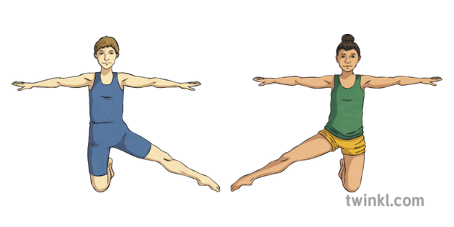

**Skills Year 3:**

To balance on points and patches with my hips higher than my head. To show my spatial awareness when I move (considering others). To create different shapes with my body. To balance on my head, with a partner supporting my legs if needed. To create interesting point and patch balances with a partner, to describe exactly what I’m doing using gymnastic vocabulary. To perform a series of rolls (forward, pencil). To jump from a small height, turning 90° or 180° and landing safely. To make shapes in the air when jumping from a small height. To travel on apparatus in different ways (forwards, backwards, sidewards, slither, crawl).

**Skills Year 4:**

To balance on my head, with my legs straight and toes pointed, with partner supporting if needed. To perform a handstand against a wall or using a partner for support. To create symmetrical and asymmetrical balances with a partner. Perform a sequence of 4 or more gymnastic movements that are linked (e.g., travel, jump, roll, stand, balance). Jump from apparatus, using my body correctly to gain height and land safely. To turn180° when jumping to the right and left. Always show a good gymnastic finishing position. To use a range of available apparatus safely, with caution. Balance on a narrow beam (upturned bench) independently. Travel showing different speeds, directions, foot patterns and levels

**Key vocabulary:**

Sequence: Two or more skills which are performed together creating a different combination skill. 90 degree and 180 degree turns. Symmetrical shapes: mirror image shape from a partner. Asymmetrical: a shape that is different on either side of the body

**RE - Why do Christians call Jesus the light of the world?**

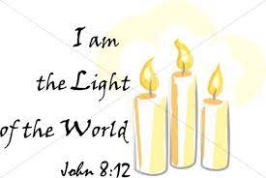

**Key Knowledge**

Christians believe that Jesus is the light of the world and he shows them the way along dark paths.

The metaphor of Jesus being the light of the world is told throughout the Bible and hymns such as ‘Colours of day’ and ‘Shine Jesus Shine’. These songs tell us the belief Christians have about Jesus.

Jesus is also portrayed as the light of the world in many pictures using a variety of colours and shapes.

Christians believe that the light of Jesus fills their hearts and that they walk in his light. This is reflected in people’s actions towards certain situations. That they bring light into the lives of those around them, family and friends.

**Key Vocabulary**

**Symbol of light:** A metaphor of the believe Christian’s have about Jesus.

**Hymns:** A religious song or poem of praise to God.

**Geography- Land-use**



**Key Knowledge and Vocabulary:**

**‘land-use’** refers to an area being used for a specific purpose.

Land uses include **urban** (towns and cities, built up areas) **rural** (countryside and farming )and **greenbelt** (rural land surrounding a town or city that cannot be built upon)

I will be able to compare how the **coastal** (a place where land meets the sea) and **market** **town** (a small town) settlements are arranged in Hartlepool.

I will be able to give reasons why these **settlements** (places where people stay) are where they are and explain how and why places are different.

To understand and explain how land use patterns in Hartlepool have changed over time, using maps and symbols.

The national land-use issue in the U.K. is increasing housing demand.

**:**