**DT – Cutting and Joining**

**Key Vocabulary.**

Cut, Slice, Push, Pull, Forwards, Backwards Press, Stick, Join, Safe

**Key Knowledge**

I can use scissors to make small snips in paper.

I can use scissors to cut a straight, curved or zig-zag line.

I can use scissors to cut around a shape

I can use a knife to cut fruit into slices.

To be safe you hold the knife by the handle.

I need an adult with me when I am using a knife.

I can join things together by using tape, split pins or tying string together.

**DT – Design and Evaluate**

**Key Vocabulary.**

Design, Make, Evaluate , Opinion, Model, Improve

**Key Knowledge**

I can think about and decide what I would like to make in the construction area.

I know what I will need to make my model.

I can tell my friend about my model and describe what I like and dislike about it.

**Music**

**Key Vocabulary**

Instrument, choose, feelings, dance, perform

**Key Knowledge**

We can use musical instruments to make music.

We can dance and perform to music.

We can use different instruments to express feelings.

Expressive Arts and Design

Personal and Social Development

**Friendship**

**Key Vocabulary**

Knife, fork, kindness, share, money, buy, cut, backwards, forwards

**Key Knowledge**

We need to treat others with kindness.

We can be kind to others by taking turns.

We can be kind to other by speaking nicely to them.

We need money to buy things we want.

We hold our knife in our right hand and our fork in our left hand.

We put our fork into the food then move backwards and forward using our knife to cut up food.

What can we imagine?

Understanding The World

**The Natural World (Science)**

**Key Vocabulary.**

Water, ice, steam, liquid, solid, pour, frozen, hot, water wheel, turn, power

**Key Knowledge**

Water is a liquid and we can pour it.

When water is frozen, it turns into ice. Ice is a solid.

When water is hot, it turns to steam.

When ice is warmed, it turns back to water.

A water wheel turns when water is poured onto it.

The water gives the wheel power to move around.

**Geography**

**Key Vocabulary.**

Protect, environment, living things, animals, plants, food, shelter, water, love, tidy, rubbish, re-use, weather, symbols, cold, mild, hot, sunny, cloudy, rain, frosty, snowy

**Key Knowledge**

We need to protect our environment.

We can look after our living things by giving them food, shelter and love.

We can look after the environment by keeping it tidy and putting our rubbish in the bin.

We can re-use materials to create things.

The weather can change each day.

We can use symbols to show how the weather is each day.

A weather map shows us what the weather is like in that place.

**Computing**

**Key Vocabulary.**

iPad, photograph, weather, bee bot, move, directions, ask, safe

**Key Knowledge**

We can use iPad’s to take photographs, such as the weather (geography link`)

A bee bot can move in different directions.

Bee bots can move around maps.

We need to ask an adult if we need help using and iPad or bee bot.

Digiducks Big Decision (throwback to internet safety)

**Religious Education-** Let’s find out about Christmas celebrations in churches.

**Key Vocabulary.Midnight, mass, Nativity**

**Key Knowledge**

Some Christians start Christmas day by joining a Midnight mass in church.

Carol services are held at Christmas which is a service with songs all about the birth of Jesus.

Christingle service celebrates Jesus coming as the light of the world.

Nativity service: On the Sunday before Christmas many churches hold a service that will include the nativity play showing the events of the first Christmas.

Nursery Rhymes

Twinkle Twinkle little Star

Hey Diddle, Diddle

Hot Cross Buns

The Wheels on the Bus

Jack and Jill

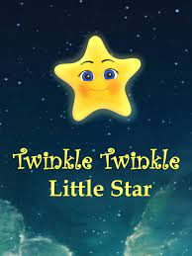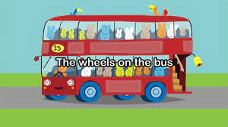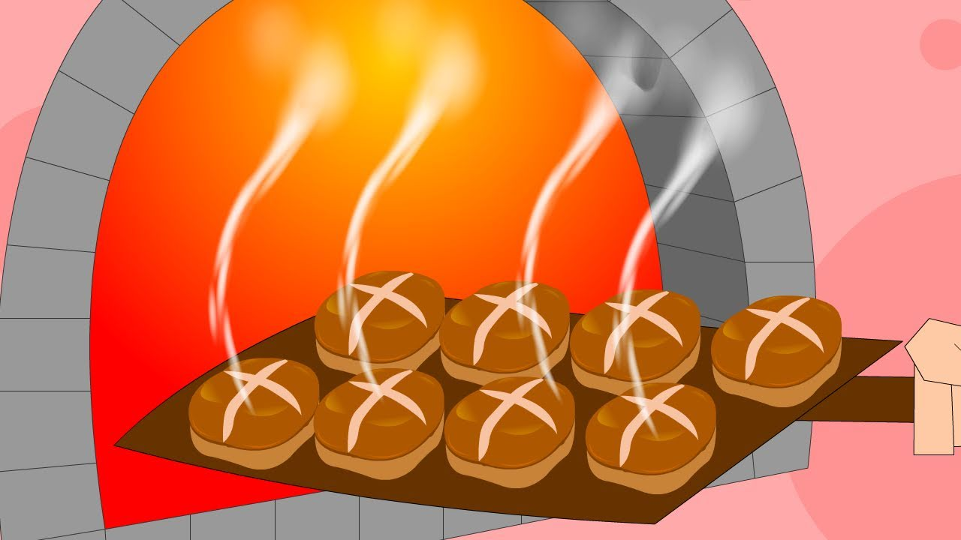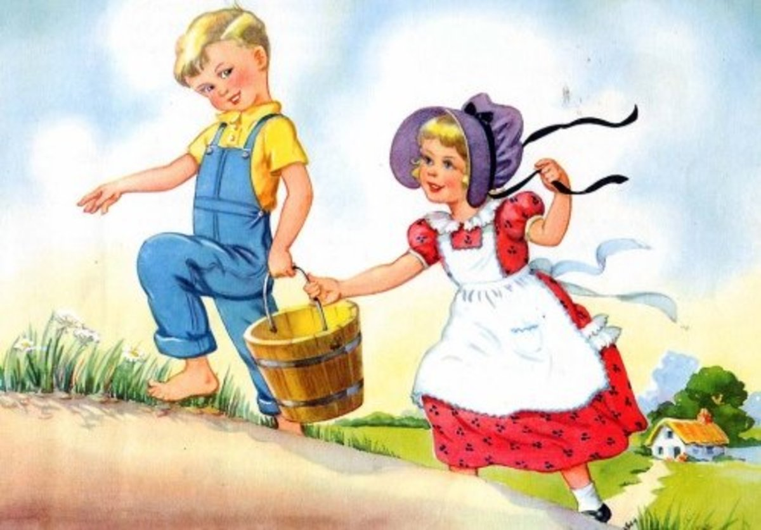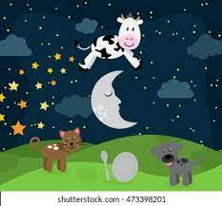

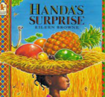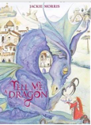

**Child Led Lines of Enquiry to Explore**

**Where does water come from?**

**How does a water wheel work?**

Stories To Explore

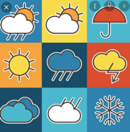

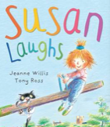

Tell me Dragon – Jackie Morris

The Paper Bag Princess – Robert Munsch

Susan Laughs – Jeanne Willis

Rapunzel

Digiducks Big Decision – Lindsay Buck

Handa’s Surprise - Eileen Browne

Tell me dragon – Jackie Morris

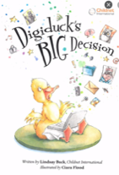

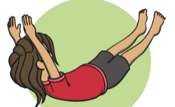

**Gross Motor - Gymnastics**

**Key Vocabulary**

Gymnast, balance, travel, move, hop, jump, roll, balance, still, crawl, hop, walk, sequence, order

**Key Knowledge**

I can travel around in different ways such as walking, running, rolling, jumping, crawling and hopping.

To balance I need to be still.

A sequence is an order of moves.

Child Led Project - Water

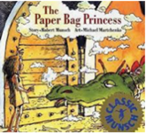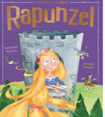

**Key Vocabulary**

Water, reservoirs, rainwater, waterwheel, power, energy, pour

**Key Knowledge**

Most water comes from rainwater.

The rainwater is collected in a reservoir.

Water from the reservoir is cleaned before it comes from our taps.

Water gives a water wheel the power to turn.

Physical Development

