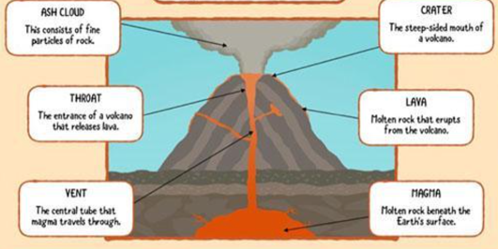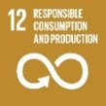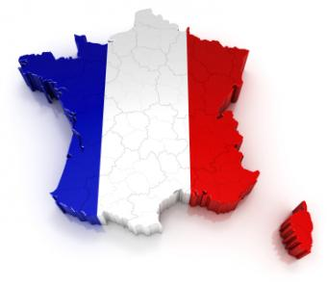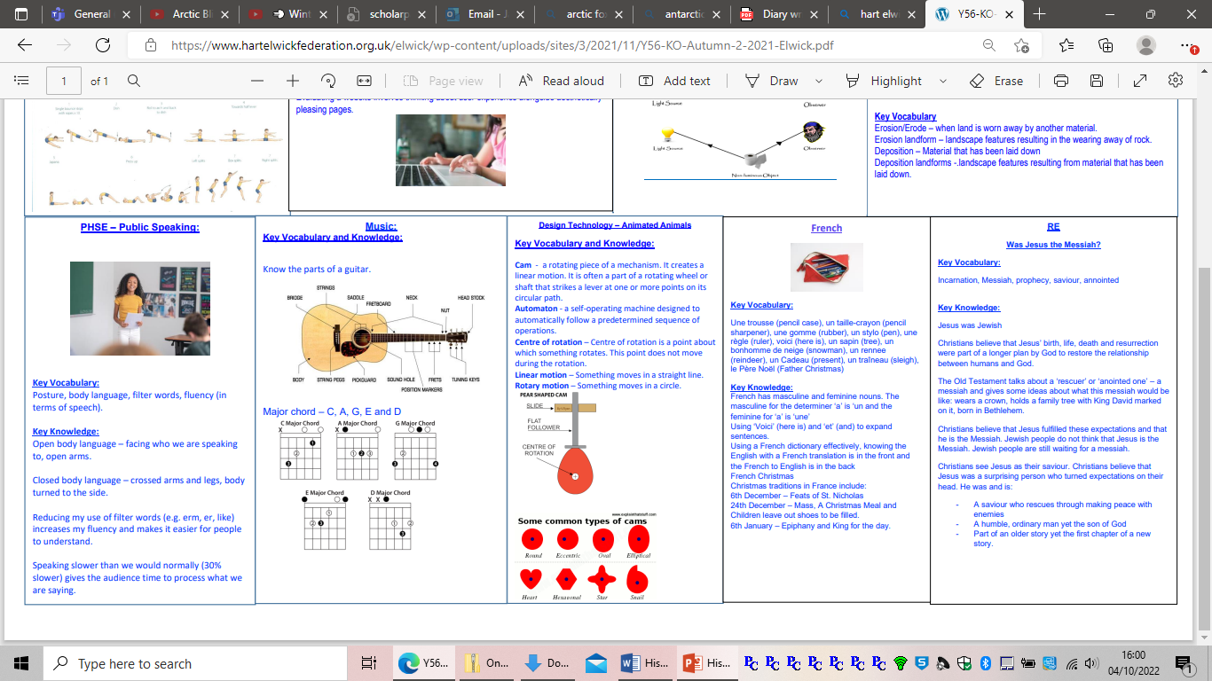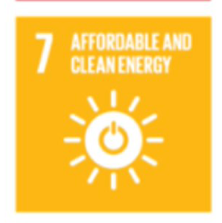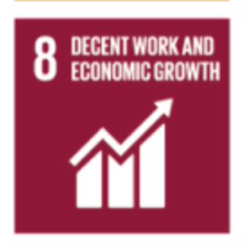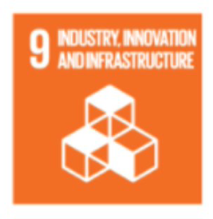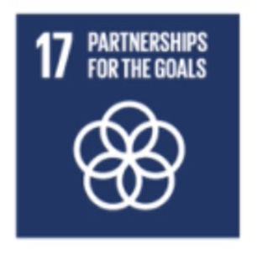

**Science**

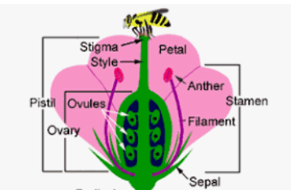**How did that get there?**

Key Knowledge:

Plants can have male and female parts as indicated on the diagram. These parts have a role in pollination and fertilisation.

Pollination – Pollination is the transfer of pollen from an anther of a plant to the stigma of another plant. This enables fertilisation to happen and seeds are produced. Some plants do not produce seeds, they produce spores.

The transfer of pollen can happen by wind or animals e.g. bees.

Bees are an important part of our ecosystem and are responsible for pollinating many of the crops we eat as well as producing honey which has a range of uses.

Sexual reproduction involves both male and female parts of the plant. Asexual reproduction happens in plants and occurs without both male and female plants e.g. strawberry plants.

Sexual reproduction in humans also involves both male and female parts.

There are similarities and differences between the life cycles of living things. I will be able to give examples of some.

French

Knowledge

C’est – it is, Ce n’est pas – it is not

Ne and pas go round the verb to make the sentence negative. We use an apostrophe because there are two vowels next to each other in ce + est and ne + est)

There are two groups of nouns in French – masculine and feminine. Un –means . a for a masculine noun. Une – means a for a feminine noun. If a colour adjective describes a feminine noun we usually add an e and pronounce the last consonant E.g. Vert become verte )

Blanche is the feminine form of blanc. A colour adjective comes after the noun. Rouge – red, Bleu/bleue – blue, Vert/verte – green, Jaune – yellow, Gris/grise – grey, Noir/noire – black, Blanc/blanche – white, Brun/brune – brown, Orange – orange, Argent –Silver, or -gold, bleu clair - light blue.

Animals Un chat (cat), Un lapin(rabbit) Une souris (mouse) Une grenouille (frog) Un cochon (pig) Un poisson(fish) Une baleine(whale) un oiseau (bird).

**Computing**

**Key Knowledge**

A text can be formatted by changing the font, style, size, and colour.

We can edit the spaces between lines of text.

Clip art or picture files can be inserted into Microsoft Word to polish a piece of writing.

You can use the skills of cut, copy and paste as a keyboard shortcut.

Headers, footers, and page numbers are used to show importance of pages within a document. They will appear on every page.

**Key Vocabulary**

**Cut –** To remove an item.   
**Copy –** Making another one which is the same.   
**Paste –** To insert an item in a new location.   
**Adjust -** To change something so it fits.    
**Headers-** A part of a document at the top which will repeat on every page.

**Footer** - A part of a document at the bottom which will repeat on every page.

**Rows –** Cells which go from right to left.   
**Columns** – Cells which go from top to bottom.

**RE: What do the Gospels tell us about the birth of Jesus?**

Key Vocabulary   
  
gentile, messiah, Matthew Luke, magi

Key Knowledge

The key events in the Christmas story include the birth of Jesus, the visitors to Jesus and the pilgrimage to Bethlehem in Nazareth.

Belief-

Jesus is the Son of God (incarnation)

That there are 2 Gospel versions of the Christmas story:

Matthew, Luke.

Luke’s gospel focuses on Mary. Luke wanted to make it clear that the Good news of Jesus is available to everyone.

Matthew: focuses on Joseph, he doesn’t mention the shepherds or magi.

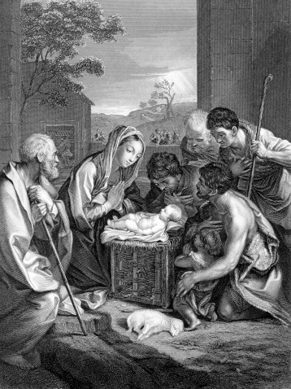

.

**Music**

**PHSE**

Rights of the Child.   
Articles:  
 12 - Respect for the views of the child.   
13 - Freedom of expression.   
14 - Freedom of thought, belief and religion. 28 - Right to education.  
 29 - Goals of education (education must develop a child’s personality, talents and abilities to the fullest).

Public Speaking

Using an appropriate voice when speaking aids public speaking e.g. tone and volume level.  
Appropriate eye contact is important when public speaking.  
Body language is key to public speaking.

People Who Inspire Us:

Ray Lonsdale – Sculpture. Creator of Local Seaham statue ‘Tommy’. Created new sculptures for Ward Jackson Park, Hartlepool.

 **British Values** 

**Key Knowledge**

To know that protected characteristics are: age, disability, gender reassignment, marriage and civil partnership, pregnancy and maternity, race, religion or belief, sex, and sexual orientation

 Everyone has the right to defence from various prejudices.

Give examples of how we can ensure people are not discriminated against.

* To understand the term democracy and why it matters.
* To begin to understand the job of the government and parliament and how they work together.
* To give their opinion and ideas on how to improve life.
* To carry out a fair voting system within their class/school and be able to analyse the outcome.
* To begin to understand how Britain is a democratic society.
* To know why we have local and general elections.
* To understand how we have the right to vote and be able to explain briefly, voting and how it has evolved within Britain.

People Who Inspire Us: Andrew Carnegie

**DT – Cross Sectional Diagrams of a chocolate bar.**

**Key Knowledge:**

A cross sectional diagram is a two-dimensional view as if it has been sliced vertically, horizontally or on a diagonal plane so you are able to see the internal structures as well as the shape of the external as a whole.

Cross-sectional diagrams are used within industry because they are useful for displaying the types of parts within an object and how they are connected together when this cannot be seen from the outside.To draw a cross sectional diagram, you must think carefully about what can be seen and what cannot. You must identify the shapes and a key may be useful to label each component as their cross section may look very different from how they look on the outside.

**Geography - Teesside Docks**

**Key Knowledge**

Our nearest county is County Durham, which borders with Tyne and Wear, Northumberland, Cumbria and North Yorkshire.

OS maps are used to locate areas in the country. They show physical and human features as symbols.

4 and 6 figure grid references locate features on maps with increasing precision.

Human and physical characteristics change over time, some examples are: new roads, railways, wind farms, the size of the channel of the River Tees and bigger docks.

Selling goods to other countries is exporting and buying goods from other countries is importing.

Sketch maps are simple maps (not drawn to scale) and only show the main features.

There are renewable and non-renewable energy sources in the UK, such as solar, hydro, wind, coal, gas and oil.

**Key Vocabulary**

County - A region of land set up with its own government

Trade – The action of buying goods and services.

Exporting – The action of selling goods or services to another country.

Importing – The action of buying goods from another country.

Dock – An area of water in a port where ships are loaded and unloaded.

**Recommended Reads – Neil Gaiman**

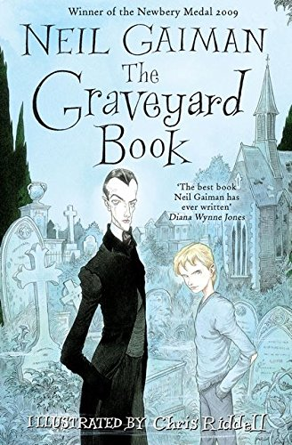 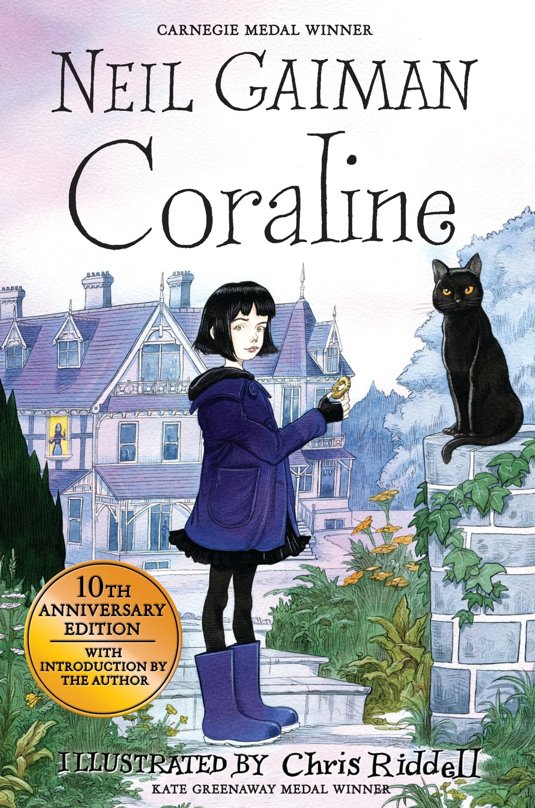 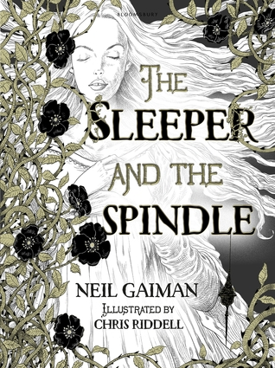

**PE**

**Gymnastics**

General vocab – accurate, refined

Body poses / positions – roll to arch, half lever, bridge, tuck, left right and box splits, press up

Roll types –  straddle, pike, jumps, star

To perform a cartwheel from a standing position, I need to be aware of my foot and hand positioning and the space around me.

To perform a handstand safely, I need to be positioned on the mat with my head and hands in a triangular shape.

When walking on a beam it is important to place feet correctly, one in front of the other.

Counter balances rely on gymnasts working in unison to support each other to balance at the same time.

