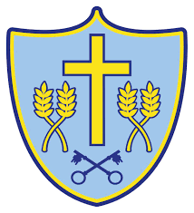

Music Scheme of Work
Cycle A | Autumn | Spring | Summer
Year 1/2 | First Thing Music  (TVMS) | My Musical Heartbeat  (Glocks) | Inventing a Musical Story  (Glocks)
Year 3/4 | Opening Night  (Glocks) | Recorders  (TVMS) | Writing Music Down  (Recorders)
Year 5/6 | Musical Structure  (Recorders) | Music and Technology  (Recorders) | Ukuleles  (TVMS)

Cycle B | Autumn | Spring | Summer
Year 1/2 | First Thing Music  (TVMS) | Exploring Sounds  (Glocks) | Playing in and Orchestra  (Glocks)
Year 3/4 | Playing in a Band  (Glocks) | Recorders  (TVMS) | Enjoying Improvisation  (Recorders)
Year 5/6 | Exploring Feelings When You Play  (Recorders) | Battle of the Bands!  (Recorders)  (Music Technology) | Ukuleles  (TVMS)

