

**Topic: RE**

**Why do Christians believe Jesus was the Messiah?**

Cycle A

Spring Term 1 Y5/6

**New Knowledge**

The People of God were taken into exile in Babylon in 586 BCE. They returned after about 50 years, but their Promised Land was still occupied by foreign forces. They begin to have a New Hope — God would rescue them. He would send a rescuer, a saviour — a Chosen One or Messiah.

Jewish followers of Jesus gradually began to believe that Jesus was the Messiah, and that he fulfilled the prophecies.

For Christians, Christmas is a time of celebration of the arrival of the Messiah.

Christians do not just believe that Jesus was an Old Testament prophet, or a messenger: they believe that Jesus was God in the flesh.

|  |  |
| --- | --- |
| Key Vocabulary | |
| Incarnation | Incarnation means ‘taking on flesh'. It is the Christian belief that God became a man in the person of Jesus. |
| Messiah | A messiah is the one believed to be sent by God to be humanity's saviour. |
| Prophecy | A prediction of what will happen in the future. |
| Saviour | Someone who rescues or saves other people from danger or even death. |
| Anointed | To make someone holy in a religious ceremony by putting holy water or oil on them. |

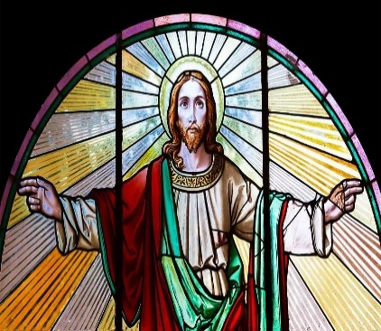

**Prior Learning**

**In Year 1 and 2 pupils learned:**

Jesus taught forgiveness.

**In Year 3 and 4 pupils learned:**

Jesus showed love for his neighbours in both his actions and stories.

**:**

**Helpful hints**

Christ’ is the Greek word for ‘anointed one’, or ‘Messiah’.