|  |  |
| --- | --- |
| New Vocabulary | |
| Trinity | The Christian belief that there is One God, who is Father, Son and Holy Spirit. |
| The Grace | A prayer which offers ‘blessings.’ |
| Gospel | The life-story or biography of the life and teaching of Jesus. |

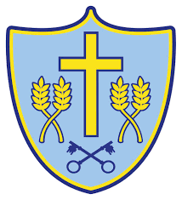

Cycle A

Spring Term 1 Y3/4

**Topic: RE What is the trinity and why is it important for Christians?**

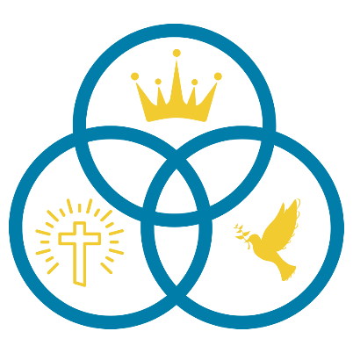

**Prior Learning**

**In Early Years, pupils learned:**

Christians believe God is behind all there is in the world.

**In Year 1 and 2 pupils learned:**

Gospel means ‘good news.’

**:**

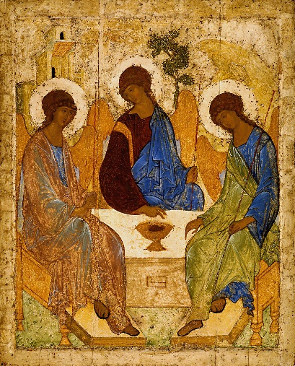

**New Knowledge**

Christians use water for baptisms because it has many different symbolic meanings.

At the very start of Jesus’ public life, it pictures the Trinity: the voice of God announces Jesus as the Son of God and the Holy Spirit is present in the form of a dove.

The Grace is a prayer, it is not addressed to God but offers a ‘blessing’ to people.

For Christians, the sense of God being with them, all around and even within their lives is a part of believing in God the Holy Spirit.

**Helpful hints**

Christians believe in one God but they believe he exists in three parts or 'persons'. These are the Father, the Son and the Holy Spirit, known collectively as the Holy Trinity.

The Holy Spirit, who is of God, is always with people to help and guide them.