|  |  |
| --- | --- |
| New Vocabulary | |
| Gospel | Gospel means ‘good news’. |
| Peace | Peace means different things to different people. It can mean being kind to other people and living with them without fights or argument. |
| Disciples | A follower of Jesus |

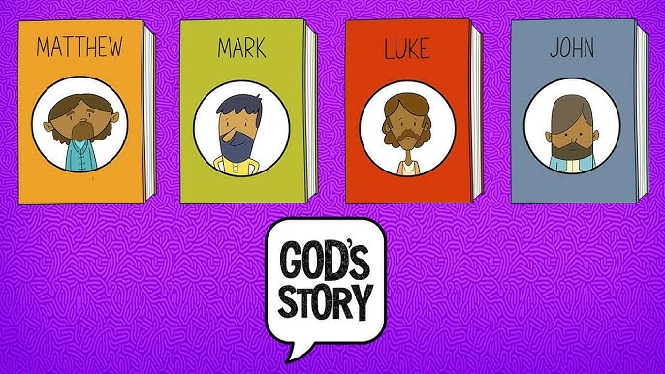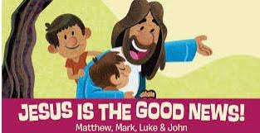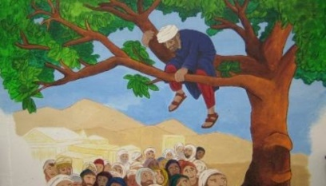

**Helpful hints**

Jesus’ first followers went through many troubles but they had peace in their hearts.

**Prior Learning**

**In Early Years, pupils learned:**

Christians are friends of Jesus. They follow the message of the Bible.

Subject Name Cycle A

Spring Term 1 Y1/2

**Topic: RE What is the ‘good news’ Christians believe Jesus brings?**

**New Knowledge**

Jesus was a friend to those left out by others.

Christian charities help people that are left out by others, just as Jesus did.

Jesus taught forgiveness and you will be forgiven.

Jesus promised peace to his disciples.

There are 4 kinds of peace – peace in our hearts, with others, peace in the world and peace with God.

Christians believe that the Gospel is good news. It shows the importance of being a friend to everyone.