|  |  |
| --- | --- |
| **New Vocabulary** | |
| secondary colours | When two primary colours are mixed together.  blue + yellow = green = red + yellow = orange  red + blue = purple |
| romanticism | An art movement which focuses on landscapes. These artists also painted with looser brushstrokes; they were less precise and filled with more movement. |
| Napoleonic War | The Napoleonic Wars were a series of battles when Napoleon ruled France. After Napoleon was defeated, the United Kingdom became one of the most powerful countries in the world. 183 – 1815 |
| colourwash | Using a large brush to spread the paint over the surface of the paper, allowing it to flow and mix. |
| drybrush technique | Using a dry brush with very little paint on allowing some of the paper to show through. Great for wood grain and clouds. |
| wet on wet | Wet paper before adding watercolours. Great for water and sky. |

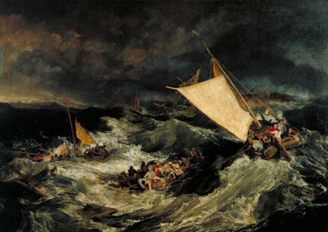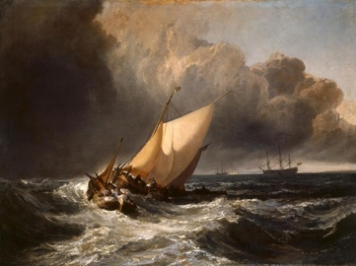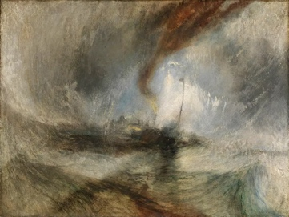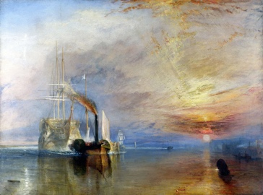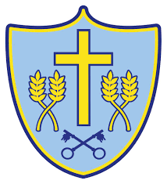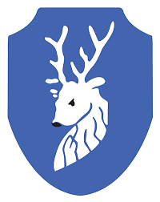

**Helpful hints**

Start with the lightest colours first when using water colours.

The more pigment you add, the more vivid and stronger the watercolours look.

When boxing up, remember to keep your boxes the same size as the image you are copying.

In general, yellows, oranges, and reds are warm colours and blues, greens and violets are cool. Adding more red and yellow tends to warm colours up. Adding blue and green tends to make them cooler.

**Prior Knowledge**

Y1/2

Hatching, scribbling, stippling, and blending can be used to create different tone (how light or dark something looks).

Observing an object means looking closely at it.

Boxing up method is used when sketching to help break up a drawing to make it easier to create.

Practiced tone by drawing light/dark lines by pressing hard and light with my pencil.

The harder I press with my pencil, the darker the shade.

Different brushes create different strokes e.g. thick, thin, curved

Colour washing means covering a large area with paint.

When you mix colours together, they create new colours.

**New Theoretical Knowledge**

Artist Studied: Joseph Turner 1775 - 1851

Joseph Turner was a romantic painter, printmaker and water colourist.

He is known for his expressive colouring, imaginative landscapes and turbulent, often violent marine paintings.

Turner liked to focus on ships and shipwrecks linked to naval battles and the Napoleonic War.

**New Disciplinary Knowledge**

**Can art tell give us clues**

**about the past?**

Art can help us understand our history, our culture, our lives, and the experience of others.

Paintings often capture details that may not have been recorded in other historical sources like writing.

Art can be used to help us understand the past showing us events that occurred.

The artist creates a story that can be interpreted in different ways.

**New Practical Knowledge**

Adding more of one colour when creating secondary colours can affect the warmth or coolness of a colour.

Texture can be created using thickened paint and mixing paint with other substances.

Watercolour can give a transparent finish and acrylic paint is thicker.

Using different brushes and strokes can affect the movement in my painting.

Tints are made with white paint and tones with grey.

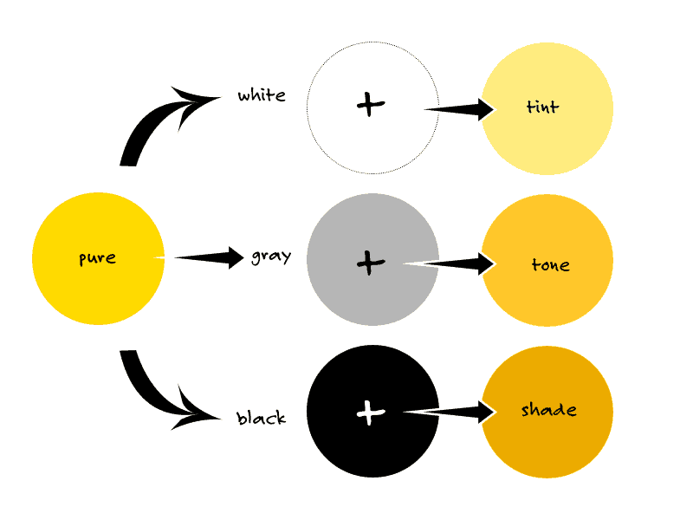

**Paradigm**: Modern Art

**Artist**: Turner

Cycle A

Autumn Term Y3/4