|  |  |
| --- | --- |
| **New Vocabulary** | |
| hatching | Closely spaces lines added to a drawing to make light or dark areas. |
| stippling | Areas of light and dark are made by using little dots. The more dots the darker the area. |
| scribbling | Quick movements with your pencil to create energy and movement. |
| blending | Two or more colours are merged together. |
| cubism | Artwork that focuses on angles and shapes. |

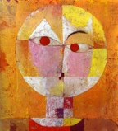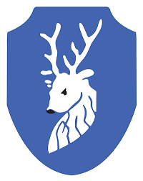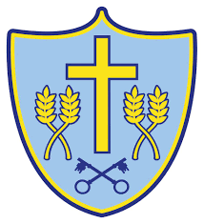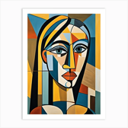

**New Disciplinary Knowledge  
Is it copying if we use the same type of style as other people?**

**Did you know?**

Copying a style helps us learn new techniques to use in our own artwork and almost every artist’s journey starts in this way.

Copying leads us to explore and find our own style and voice.

**Top tips**

Try to draw lightly so that you can rub out mistakes easily.

Remember to think about how you can turn the features of your face into bold shapes like diamonds for eyes.

Be adventurous! Cubism is not supposed to look like a photograph. It will look strange and different and that’s okay!

**Prior Knowledge**

Y1/2

Mixing Colours

Mixing two colours together changes the colour. Adding black makes a colour darker and adding white makes it lighter.

Painting

Different size brushes make different paint strokes. Adding more water make paint more see-through (transparent)

EY

Drawing

When drawing a portrait, you need to include facial features that are the correct size and in the correct place.

Mixing Colours

Colour names – red, blue, yellow, green, pink, white, grey, black, purple, gold, silver, orange. Adding more power paint makes my paint thicker.

Drawing

When drawing a portrait, you need to include facial features.

**New Practical Knowledge**

The proportions of the face are:

Colours can express emotions.

A colourwash is a background painted with a large brush.

Tone is how light or dark something looks.

Investigating tone is using different pressure with my pencil to make light or dark lines.

Evaluating artwork is looking at artwork and giving my opinion.

**New Theoretical Knowledge**

**(Artist Context)**

Artist Study: Pablo Picasso & Paul Klee

Paul Klee - German artist. Influenced by cubism (artwork that looks at shapes of objects), and surrealism (art inspired by dreams).

He was influenced by Pablo Picasso.

Pablo Picasso - Son of an art teacher. Spent most of his life in France. Picasso became friends with lots of artists like Georges Braque who he invented cubism. Picasso created different types of cubism and influenced other artists like Klee.

Cycle A

Spring Term Y1/2

**Paradigm**: Modern Art

**Artist**: Paul Klee & Pablo Picasso