|  |  |
| --- | --- |
| **Dance Vocabulary** | |
| action | A movement. |
| sequence | More than one movement after another. |
| link / join | When I put two movements together. |

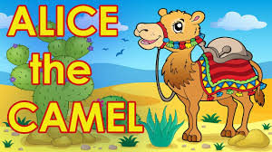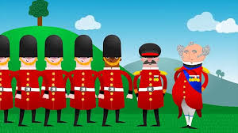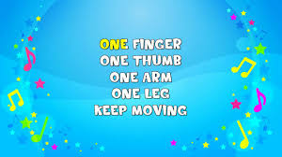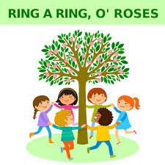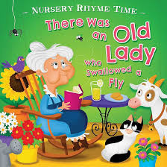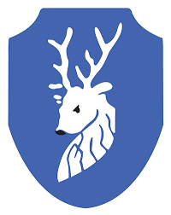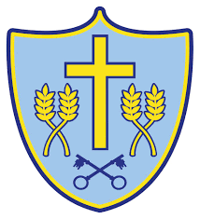

**New Knowledge – Practical**

**Movement**

A fast action means moving quickly.

A slow action means moving slowly.

**Performance**

There is a start and finish to a sequence.

A performance has more than one action.

There are high dance moves and low dance moves.

You can use any part of your body in a performance – hands, feet, head etc.

You can clap or move a body part to a song.

**By the end of EYFS, the children will know the following knowledge about dance.**

**Area of PE**: Dance

**New Knowledge - Rhymes**

There was an old lady who swallowed a fly.

One finger one thumb, keep moving.

Alice the camel.

Ring a ring o’roses.

The grand old Duke of York.

Spring Term 1

EYFS