

Subject Name Cycle A

Spring 1 - EYFS

**Topic: RE- Why is the word ‘God’ so important to Christians?**

**New Knowledge**

The word God is important as it is the name of someone very important to Christians: the Creator of the universe.

Christians show that God is important to them in church when they gather together to pray to God and to sing his praise.

A church is a Christian place of worship.

Worship is about people showing how much God is worth to them.

Harvest is an opportunity to give thanks to God the creator and provider.

Christians are taught to respect God’s name and use it with love and care because God is holy and great.

The Lord’s Prayer is the most well-known prayer.

The Ten Commandments show people to treat God as holy.

|  |  |
| --- | --- |
| **New Vocabulary** | |
| Baptism | A religious ceremony to welcome a person into Christianity. |
| Dedication | To give time to something that is important to you. |
| Valued | How important something/someone is. |
| Welcomed | To be met by people in a warm and friendly way. |
| Holy | Holy means more than special. Christians believe God is holy - he is perfect and greater than everyone or everything. |

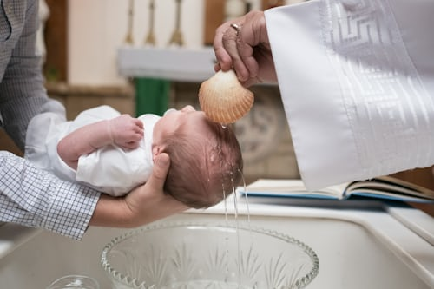

**Helpful hints**

Christians believe God is behind all there is in the world. They believe that God is the giver of life.