Sally Robinson, Director
CLASSIFICATION – Confidential
Children’s and Joint Commissioning Services Tel: 01429 523942
Civic Centre
Hartlepool www.hartlepool.gov.uk
TS24 8AY DX 60669 Hartlepool - 1

Contact Officer: Craig Blundred Our Ref: 15 – CB/SR
Email: craig.blundred@hartlepool.gov.uk Your Ref:

24 January 2022

When telephoning, please ask for:
Craig Blundred
Direct Line: (01429) 284104

Dear Parents/Carers

Measures to protect pupils, staff and face to face education

Following the recent Government Announcement of the relaxation of plan B measures, I wanted to highlight with you that, although the rates of covid-19 infections across Hartlepool are declining, the current rates are still approximately four times higher than they were when Plan B was implemented in December 2021.

With our current high rates amongst 0-19 year olds, we are supportive of your school implementing additional measures to protect pupils, staff and the broader community, based on their individual risk assessments. The Public Health team will be working closely with Head Teachers to support the implementation of temporary and proportionate additional covid-19 measures when needed, based on their individual school situations.

Schools and parents continue to play a critical role in helping to keep the wider community safe through all the work you are doing around testing, vaccinations and infection control. I share your priority to ensure your children can continue to receive face-to-face education, which at times may mean additional measures are implemented in your child’s school setting.

We are continuing to monitor the situation and work with your school closely on a daily basis.

Yours sincerely,

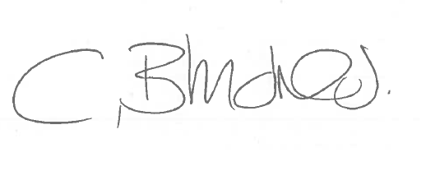

CRAIG BLUNDRED SALLY ROBINSON
Director of Public Health Director of Children’s and Joint Commissioning Services

