

If you have a concern about an adult, find and tell…

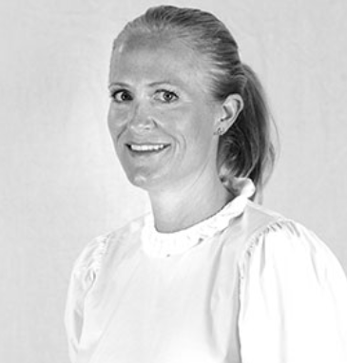

Mrs K Hill



Mrs V Wilson



Mr C Reid

(governor)

If you have a concern about a child, find and tell…



Mrs V Wilson

Designated Safeguarding Lead



Mrs K Hill

Deputy Designated Safeguarding Lead

**Designated Safeguarding Leads**

St Peter’s Elwick Church of England Primary School strives for a culture of vigilance. Staff and governors are committed to keeping children safe. Share that commitment by…